Crossed Square Cupola
# Source: AI Source: Provided by: [Data Path: Persons Table -> ID Column: 1, Name_En Column: Motasem Essam] -> From: [ChatGPT] on [7/25/2026]
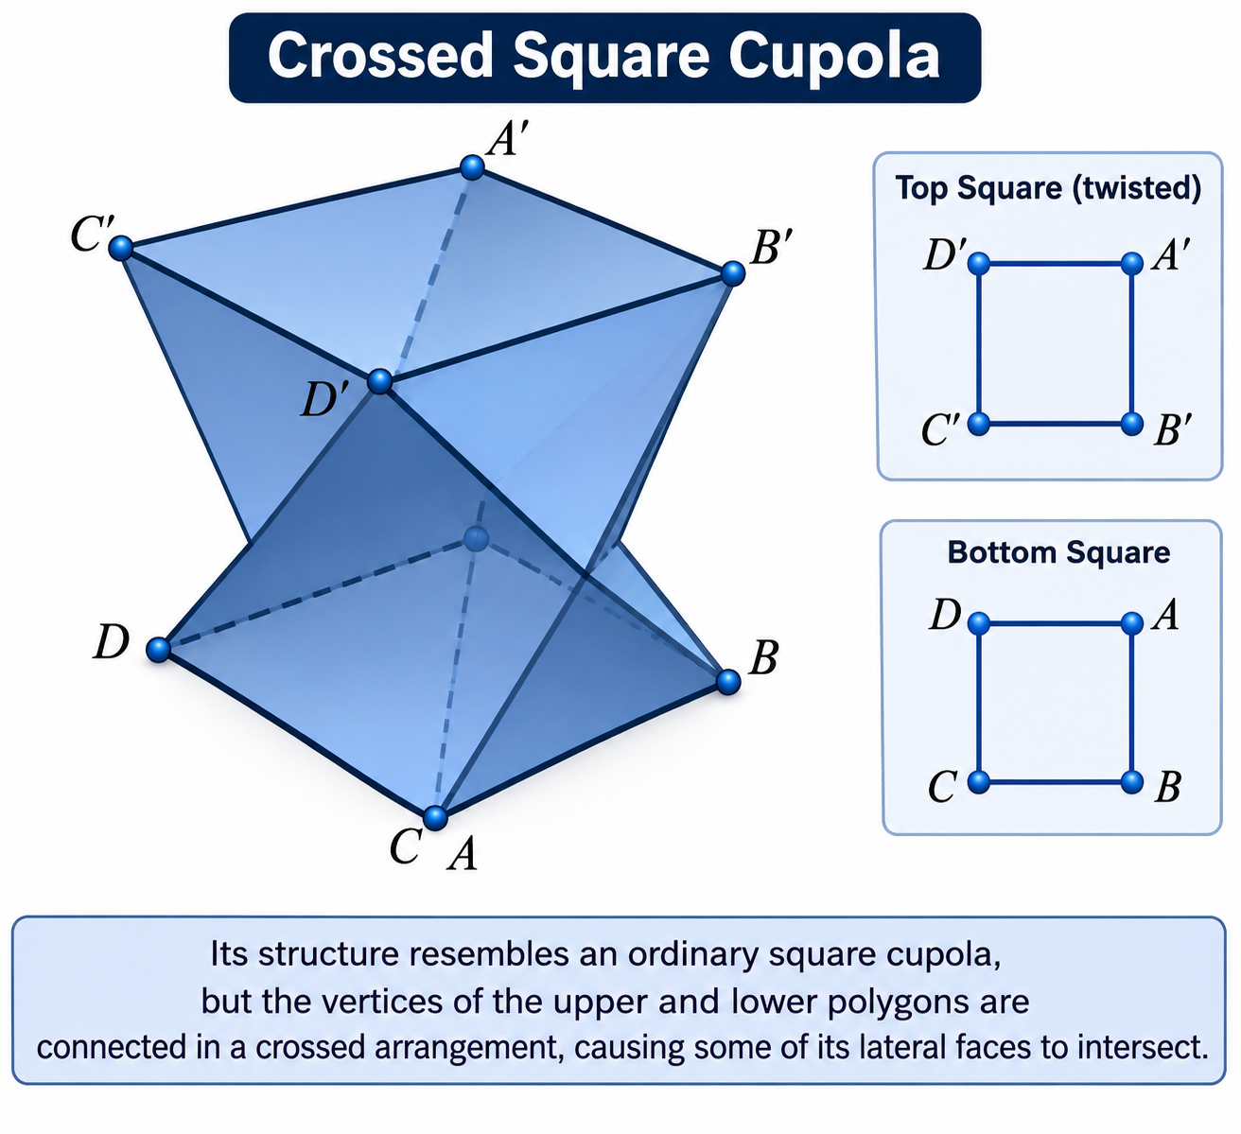

Definition
# Source: AI Source: Provided by: [Data Path: Persons Table -> ID Column: 1, Name_En Column: Motasem Essam] -> From: [ChatGPT] on [7/25/2026]
A Crossed Square Cupola, also known as a 4/3-Cupola, Retrograde Square Cupola, or {4/3}-Cupola, is a non-convex star-cupola formed by connecting a retrograde square upper polygon to a crossed octagonal lower polygon.
Its structure resembles an ordinary square cupola, but the vertices of the upper and lower polygons are connected in a crossed arrangement, causing some of its lateral faces to intersect.
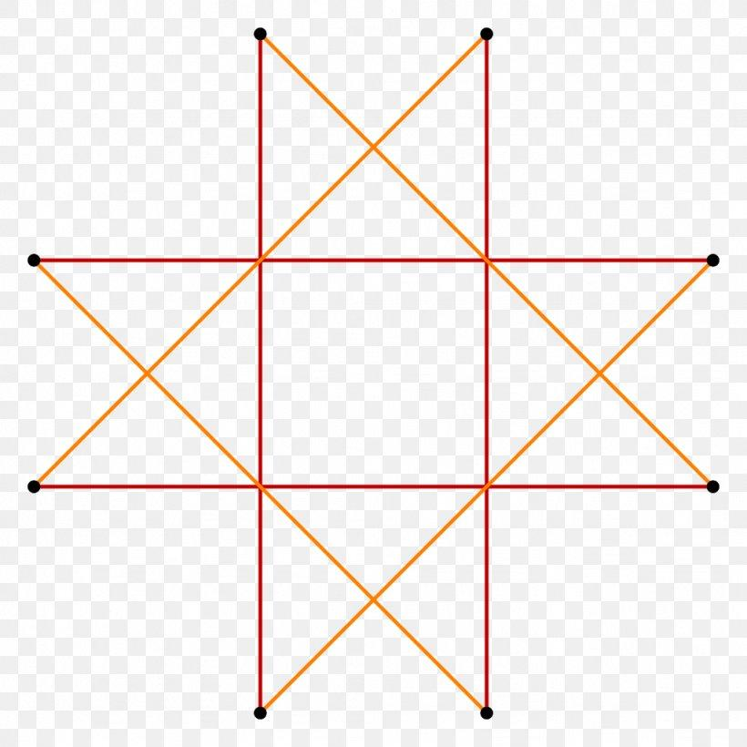

Geometric Structure
# Source: AI Source: Provided by: [Data Path: Persons Table -> ID Column: 1, Name_En Column: Motasem Essam] -> From: [ChatGPT] on [7/25/2026]
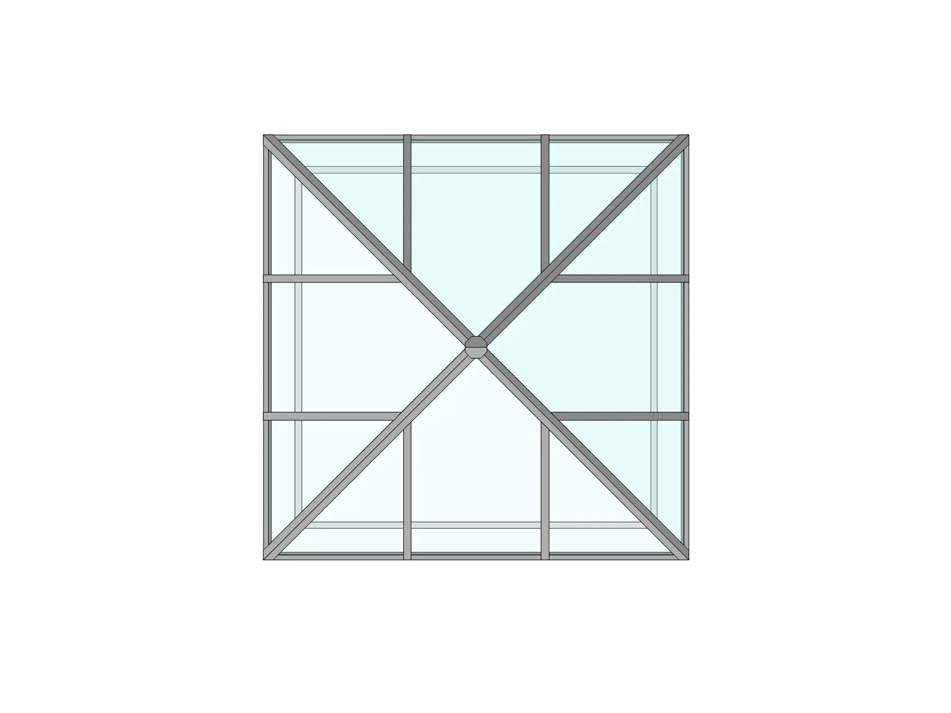
The Crossed Square Cupola consists of:
- Upper Base: A retrograde square represented by the star-polygon notation $\{4/3\}$.
- Lower Base: A crossed octagon (octagram) represented by $\{8/3\}$.
- Triangular Faces: Four triangular lateral faces.
- Square Faces: Four lateral square faces.
- Crossed Arrangement: The lateral faces connect the two bases in a retrograde configuration.
<Cite refs={["turn857728search0","turn857728search2"]}/>

Face Composition
# Source: AI Source: Provided by: [Data Path: Persons Table -> ID Column: 1, Name_En Column: Motasem Essam] -> From: [ChatGPT] on [7/25/2026]
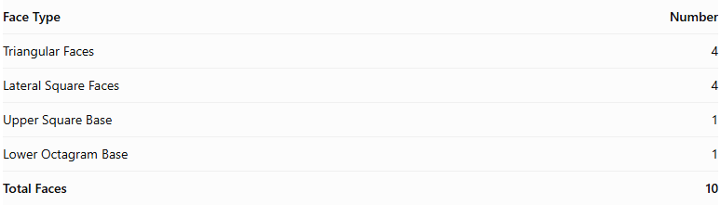
Face Type | Number
Triangular Faces | 4
Lateral Square Faces | 4
Upper Square Base | 1
Lower Octagram Base | 1
Total Faces | 10
The upper square and lower octagram are star-polygon bases, while the remaining eight faces form the lateral structure. <Cite refs={["turn857728search2","turn857728search3"]}/>

Mathematical Properties
# Source: AI Source: Provided by: [Data Path: Persons Table -> ID Column: 1, Name_En Column: Motasem Essam] -> From: [ChatGPT] on [7/25/2026]
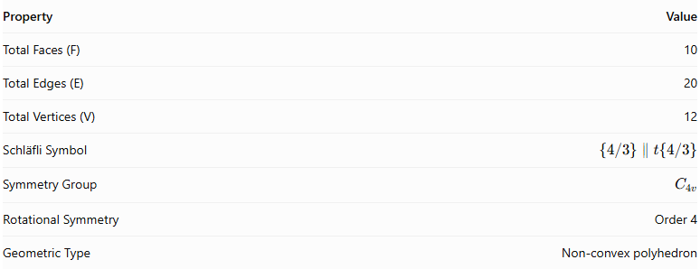
Property | Value
Total Faces (F) | 10
Total Edges (E) | 20
Total Vertices (V) | 12
Schläfli Symbol | $$\{4/3\}∥t\{4/3\}$$
Symmetry Group | $$C_{4v}$$
Rotational Symmetry | Order 4
Geometric Type | Non-convex polyhedron
<Cite refs={["turn857728search2","turn857728search6"]}/>
Euler's Polyhedron Formula:
$$V-E+F=2$$
$$12-20+10=2$$

Geometric Characteristics
# Source: AI Source: Provided by: [Data Path: Persons Table -> ID Column: 1, Name_En Column: Motasem Essam] -> From: [ChatGPT] on [7/25/2026]
- Non-Convex Structure: The crossed arrangement produces intersecting parts of the polyhedron.
- Retrograde Upper Base: The upper base follows the $\{4/3\}$ vertex sequence.
- Octagram Lower Base: The lower base follows the $\{8/3\}$ star-polygon sequence.
- Fourfold Rotational Symmetry: The structure repeats after a rotation of ${90}^{∘}$.
- Cupola Construction: It retains the general cupola arrangement of triangular and square lateral faces.
- Johnson Solid Isomorph: It is topologically related to the convex Square Cupola, but is non-convex and is not itself one of the 92 convex Johnson solids. <Cite refs={["turn857728search2","turn857728search1"]}/>

Constructing Crossed Square Cupola in Solid Geometry

Geometric Instruments Used
# Source: AI Source: Provided by: [Data Path: Persons Table -> ID Column: 1, Name_En Column: Motasem Essam] -> From: [ChatGPT] on [7/25/2026]
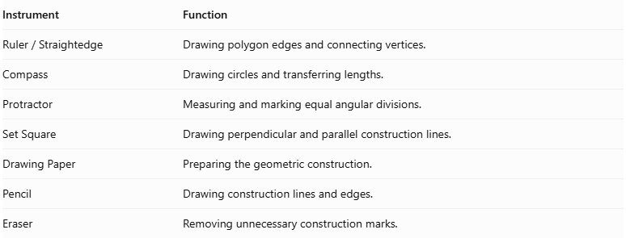
Instrument | Function
$$Ruler/Straightedge$$ | Drawing polygon edges and connecting vertices.
Compass | Drawing circles and transferring lengths.
Protractor | Measuring and marking equal angular divisions.
Set Square | Drawing perpendicular and parallel construction lines.
Drawing Paper | Preparing the geometric construction.
Pencil | Drawing construction lines and edges.
Eraser | Removing unnecessary construction marks.

Instrument-Based Construction Procedures

Constructing the Lower Octagrammic Base
# Source: AI Source: Provided by: [Data Path: Persons Table -> ID Column: 1, Name_En Column: Motasem Essam] -> From: [ChatGPT] on [7/25/2026]
- Draw a circle using a compass.
- Mark its center.
- Divide the circumference into eight equal angular sections.
- Each central angle measures:
$$\frac{{360}^{°}}{8}={45}^{°}$$
- Mark the eight equally spaced points around the circle.
- Starting from one point, connect every third point in sequence.
- Continue until the sequence returns to the starting point.
- Complete the octagram $\{8/3\}$.
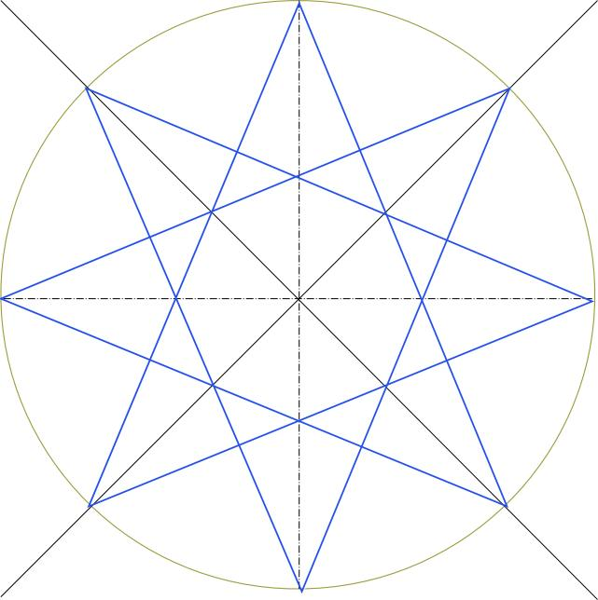

Constructing the Upper Retrograde Square
# Source: AI Source: Provided by: [Data Path: Persons Table -> ID Column: 1, Name_En Column: Motasem Essam] -> From: [ChatGPT] on [7/25/2026]
- Draw a second circle using a compass.
- Divide it into four equal angular sections.
- Each central angle measures:
$$\frac{{360}^{°}}{4}={90}^{°}$$
- Mark the four vertices.
- Connect the vertices in the reversed traversal order to represent the retrograde square $\{4/3\}$.
- Complete the upper square.
The reversed traversal describes the polygon's orientation; it does not create a different square outline.
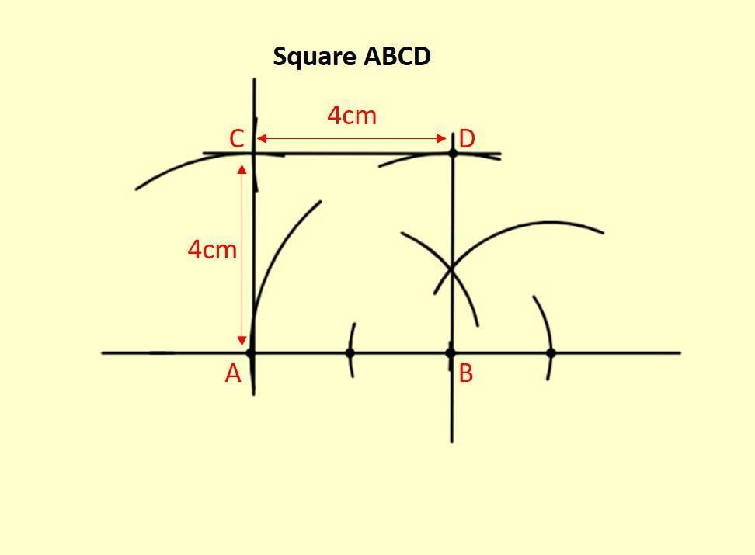

Positioning the Two Bases
# Source: AI Source: Provided by: [Data Path: Persons Table -> ID Column: 1, Name_En Column: Motasem Essam] -> From: [ChatGPT] on [7/25/2026]
- Draw the octagrammic base in the lower position.
- Draw the square above it.
- Keep the intended base planes parallel.
- Align the square and octagram according to the crossed cupola arrangement.
- Maintain the four-fold rotational symmetry.
- Preserve the retrograde orientation instead of using the ordinary square cupola's face arrangement.

Constructing the Four Lateral Square Faces
# Source: AI Source: Provided by: [Data Path: Persons Table -> ID Column: 1, Name_En Column: Motasem Essam] -> From: [ChatGPT] on [7/25/2026]
- Identify the four square-face positions around the cupola.
- Attach each square to the appropriate alternating edges of the octagrammic base.
- Connect the corresponding upper and lower vertices.
- Follow the crossed arrangement so the lateral faces have the intended intersections.
- Check the connections against the neighboring triangular faces.

Constructing the Four Triangular Faces
# Source: AI Source: Provided by: [Data Path: Persons Table -> ID Column: 1, Name_En Column: Motasem Essam] -> From: [ChatGPT] on [7/25/2026]
- Identify the four gaps between the lateral square faces.
- Connect the appropriate remaining vertices of the upper and lower structures.
- Form four triangular lateral faces.
- Ensure that the triangles complete the alternating face arrangement.
- Preserve the intended intersections between the crossed parts.

Completing the Three-Dimensional Representation
# Source: AI Source: Provided by: [Data Path: Persons Table -> ID Column: 1, Name_En Column: Motasem Essam] -> From: [ChatGPT] on [7/25/2026]
- Review all ten faces.
- Check the connections between the octagrammic base, upper square, and lateral faces.
- Distinguish visible edges from hidden edges.
- Use different line styles to indicate intersecting or obscured edges.
- Add shading to distinguish the triangular and square faces.
- Verify that the result represents a crossed rather than an ordinary square cupola.
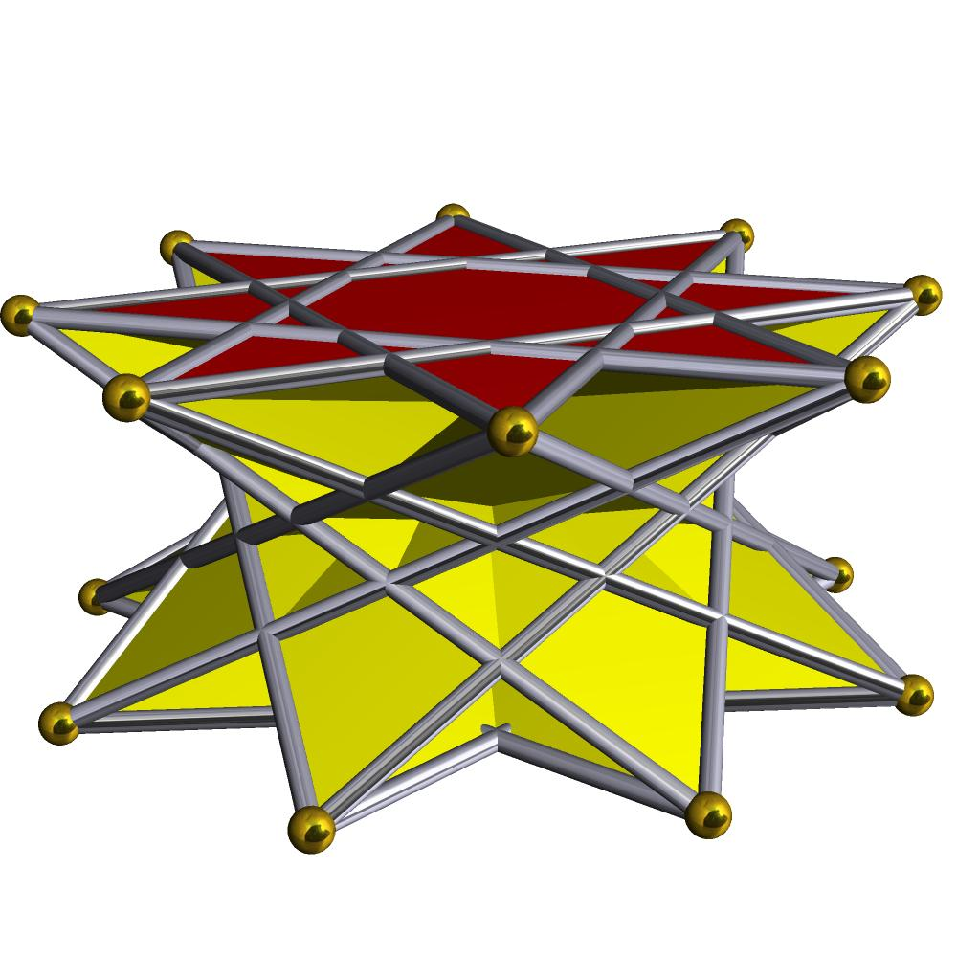

Key Points
# Source: AI Source: Provided by: [Data Path: Persons Table -> ID Column: 1, Name_En Column: Motasem Essam] -> From: [ChatGPT] on [7/25/2026]
- Alternative Names: 4/3-Cupola, Retrograde Square Cupola, {4/3}-Cupola.
- Upper Base: Retrograde Square.
- Lower Base: Octagram.
- Lateral Faces: 4 Triangles and 4 Squares.
- Total Faces: 10.
- Total Edges: 20.
- Total Vertices: 12.
- Classification: Non-convex Star-Cupola.

Main Classification
# Source: AI Source: Provided by: [Data Path: Persons Table -> ID Column: 1, Name_En Column: Motasem Essam] -> From: [ChatGPT] on [7/25/2026]
Solid Geometry
└── Types of Solids
└── Star-Cupola
└── Types of Star-Cupola
└── Crossed Square Cupola

Conclusion
# Source: AI Source: Provided by: [Data Path: Persons Table -> ID Column: 1, Name_En Column: Motasem Essam] -> From: [ChatGPT] on [7/25/2026]
The Crossed Square Cupola is a non-convex star-cupola characterized by its retrograde square upper base, octagram lower base, and crossed lateral arrangement of triangular and square faces. It has 10 faces, 20 edges, and 12 vertices, with fourfold rotational symmetry.

